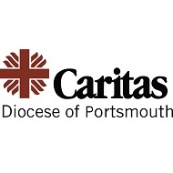
13th November 2020

Dear Parents
Pope Francis says “a Church without charity does not exist”. Caritas, inspired by the Gospel values and the Catholic Social Teaching, responds to disasters, promotes integral human development and advocates on the causes of poverty and conflict.
This year they are holding a Christmas appeal to provide each child looked after by Children’s Services with a present for Christmas. They would normally ask for donations of gifts, but in the current climate, are happy to receive monetary donations to enable the gifts to be purchased centrally.
We will therefore be holding a Non-Uniform Day on Friday 4th December to raise money to enable Caritas to purchase Christmas presents for those children who are most in need in our community. The children will be able to wear their own clothes in exchange for £1.
If, in addition to your £1 donation, you would like to provide a gift for a child between the ages of 0 and 19, we are happy to collect these presents and ensure they are collected by Caritas for distribution as appropriate.
If you have any queries, please do not hesitate to contact the school office.
Yours sincerely

Mrs Ridguard-Thomas

Mrs Ridguard-Thomas
Head of RE

